Maven Configuration

This section will guide you to:

* Install and configure Maven for Selenium Project in Eclipse.

This guide has mainly four sub-sections, namely:

1. Installing Maven in Eclipse

2 Creating a Maven project

3 Adding Maven dependencies

4 Pushing the code to your GitHub repositories

**Step 1:** Installing Maven in Eclipse

1. Maven integration for Eclipse is already installed in your Practice lab. Refer to QA to QE lab guide for Phase 2 for more information.

**Step 2:** Creating a Maven project

1. Open Eclipse.
2. Click on File->New->Maven project.

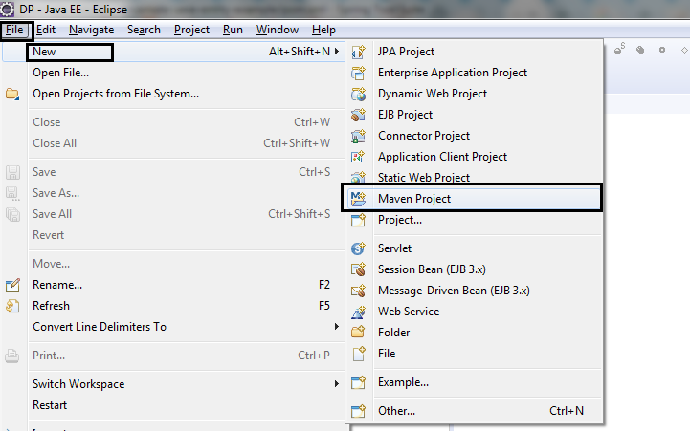

1. Select the default workspace location.
2. Click on **Next**.

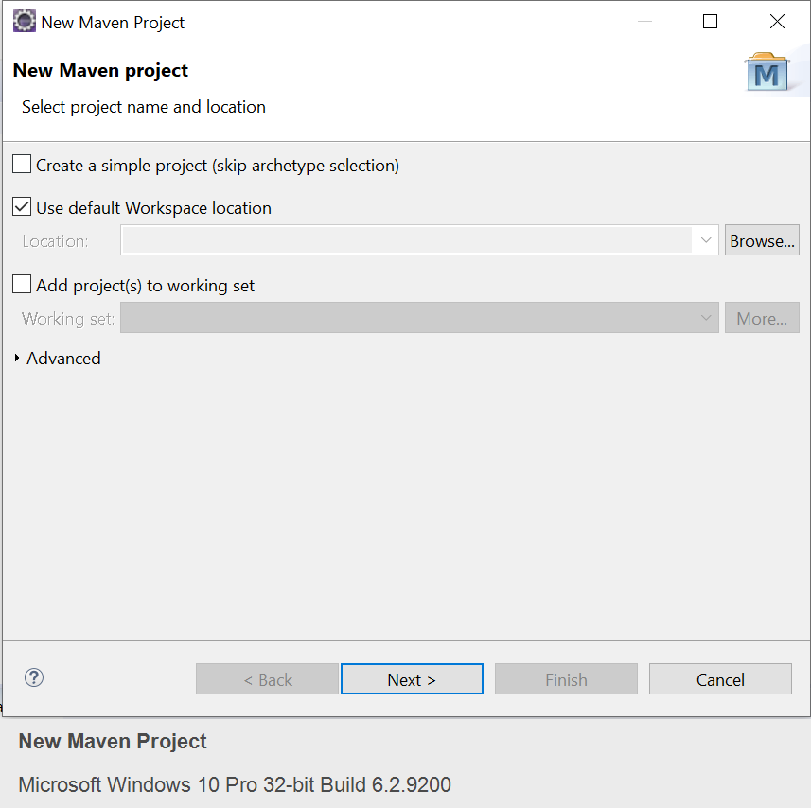

1. Select the Maven archetype as maven-archetype-webapps and click on **Next**.

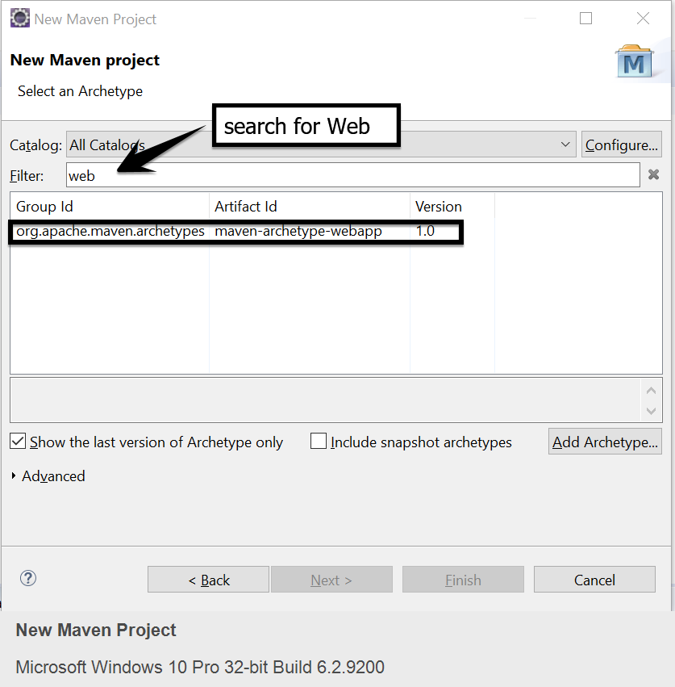

1. Enter the Group ID and Artifact ID and click on **Finish**.

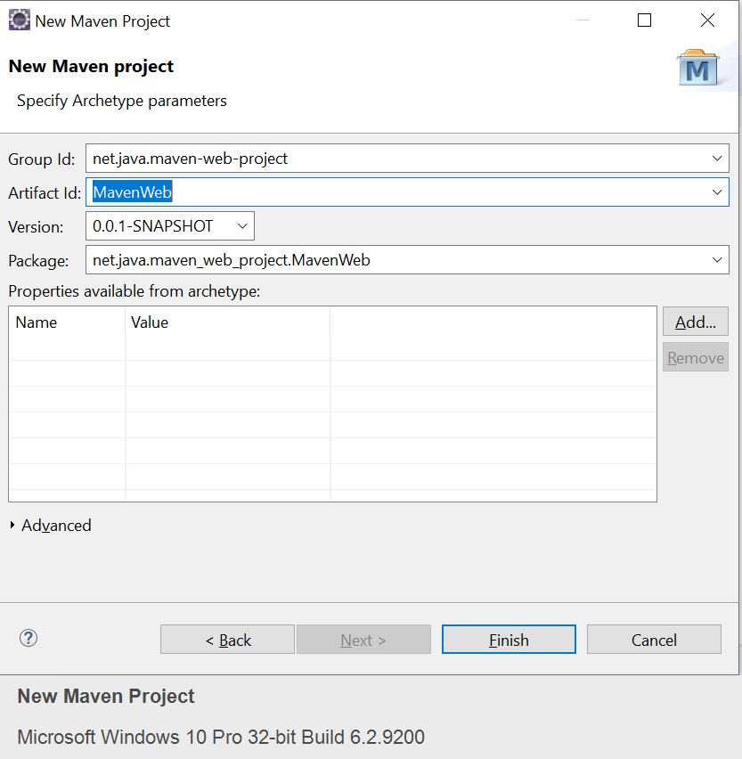

1. You are all set. The new Maven structure will look like the below screenshot:

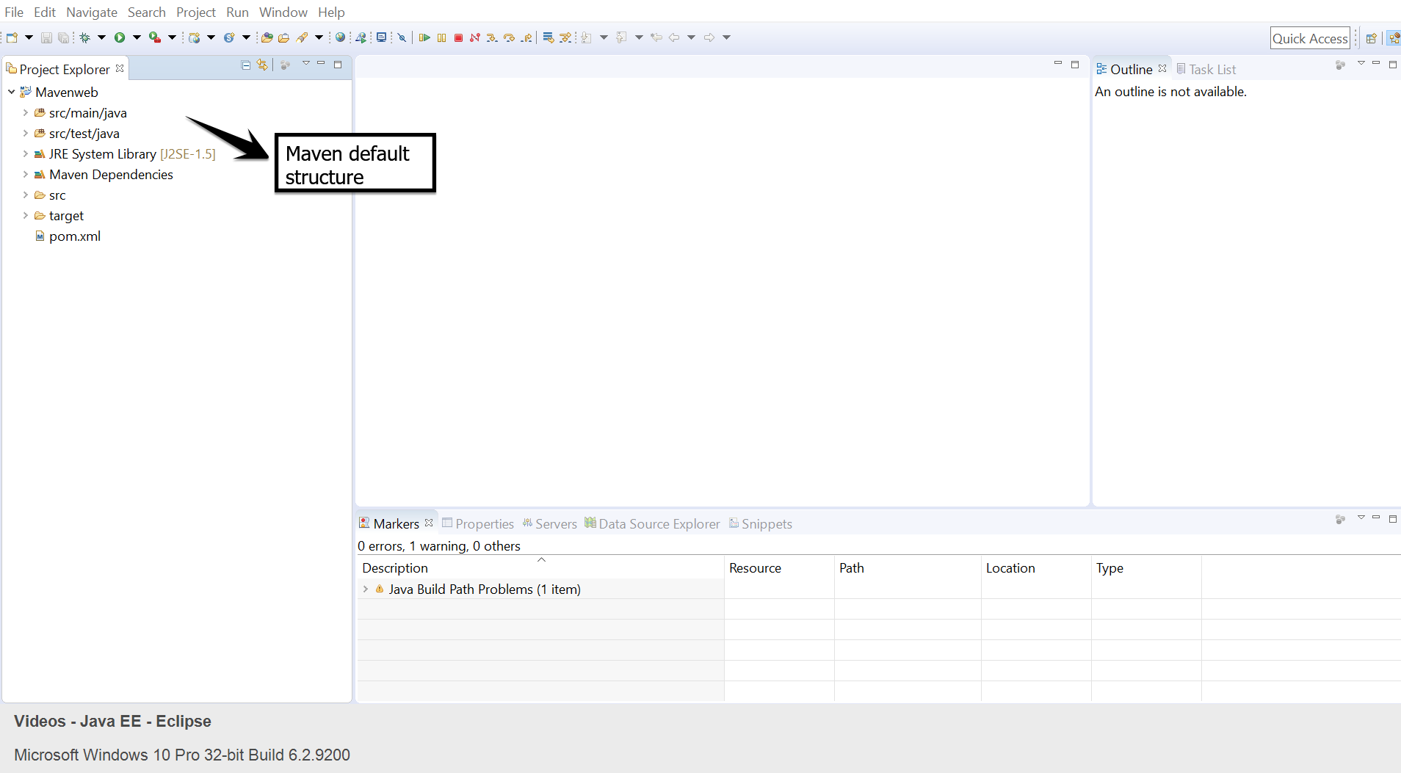

**Step 3:** Adding Maven Dependency

* If we are using the Selenium web driver, then we need to specify the Selenium web driver dependencies to our pom.xml.

1. Go to Maven Repository: <https://mvnrepository.com/artifact/org.seleniumhq.selenium/selenium-java/3.14.0>
2. Copy the dependency.

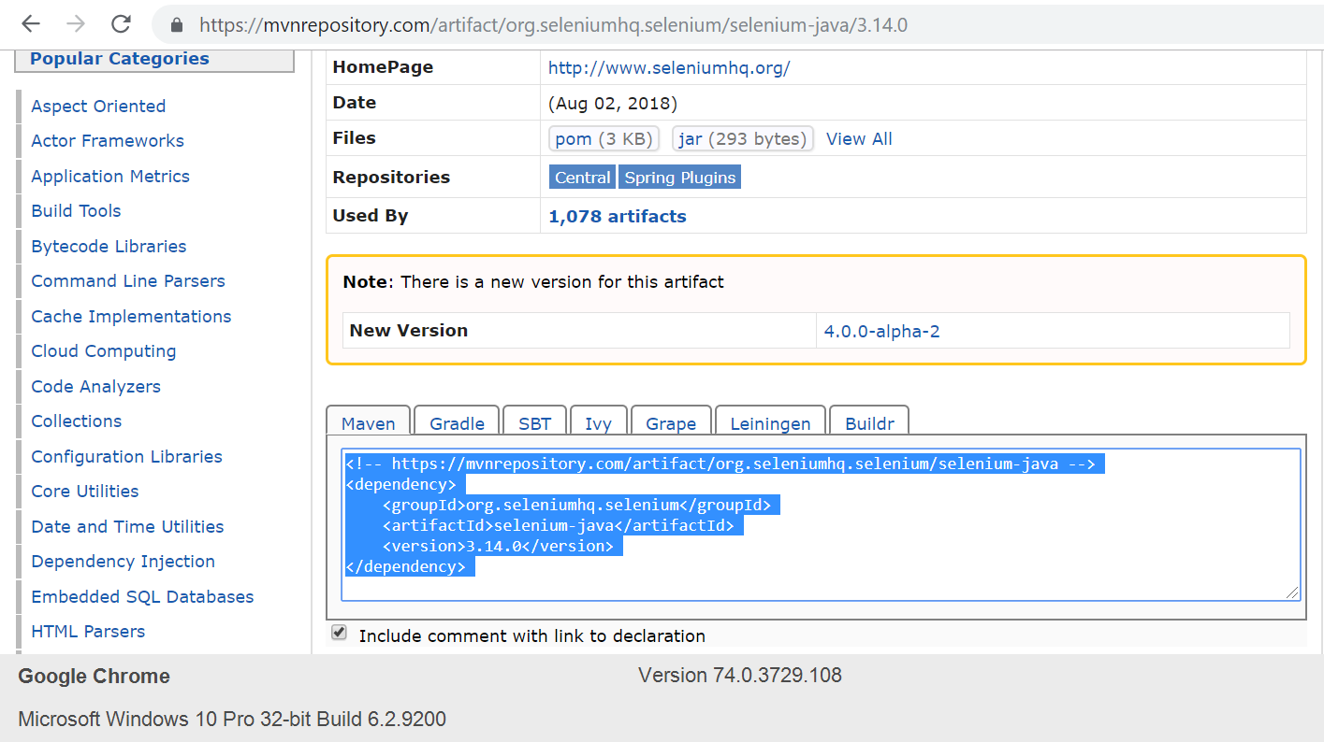

1. Go to Eclipse.
2. Open the Pom.xml file from the project.
3. Paste the dependency in the Pom.xml file:

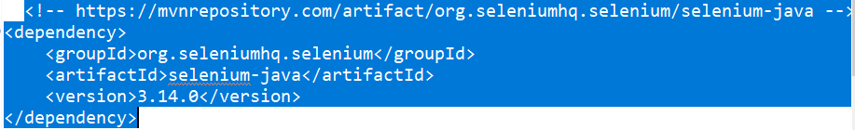

* If we are using TestNG, then we need to specify the TestNG dependencies to our pom.xml

1. Go to the Maven Repository: <https://mvnrepository.com/artifact/org.testng/testng/6.8>
2. Copy the dependency.

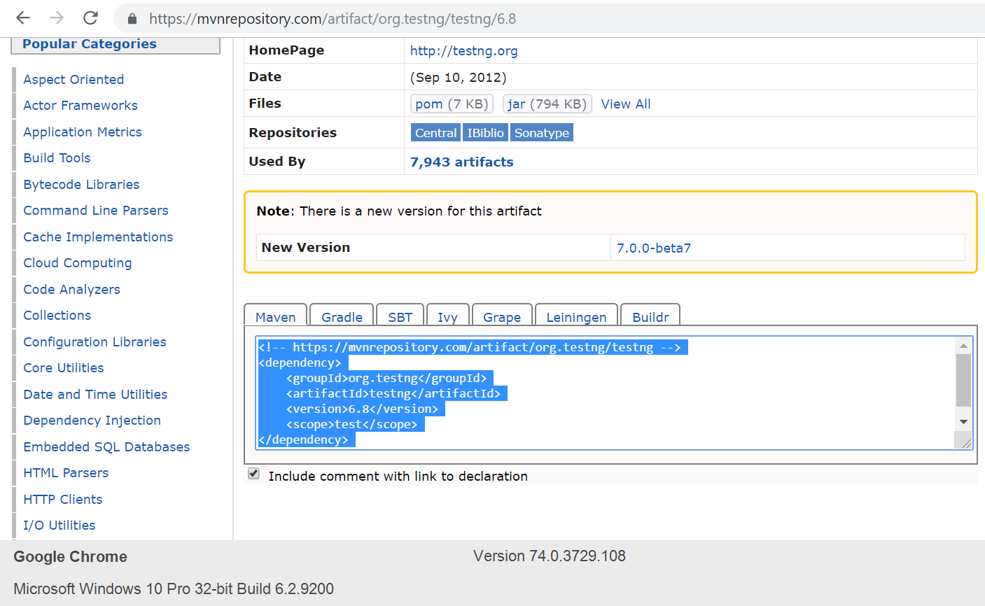

1. Go to Eclipse.
2. Open the Pom.xml file from the project.
3. Paste the dependency in the Pom.xml file:

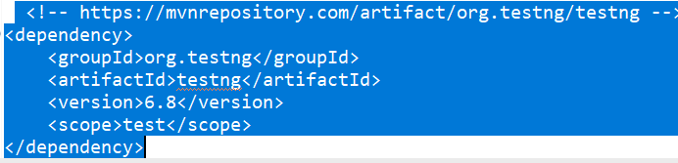

1. This is what the Maven dependencies will look like in the pom.xml file.

